Date 30 Oct 2012

To migrate the old Labeling program into current APHUB outbound Hub application.
This is to consolidate all sub-programs into single application. The functions are remaining the same.

The old version of labeling system:  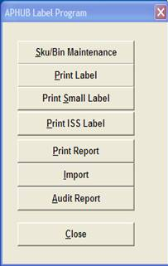 | New Hub Label: (standard-3162)  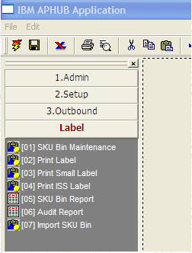

The new set of application for new BO onboard will be under folder -> [Label-3N62]

